
Център за обучение по софтуерно тестване Website: http://skillo-bg.com
Bug Template
Bug ID | OnlineStore_B001
Name | Sorting by highest price not working properly
Priority | P1
Severity | S3
Description | Sorting in dress section by price is not working properly
Steps to reproduce | Step1: Open site http://www.onlinebills.com  Step2: Choose Dress category  Step3: Select from Sort by drop down list  Step4: Choose “Price: Highest first”  Expected result: Shown items by highest price first  Actual result: The items are sorting by lowest price
Attachment | 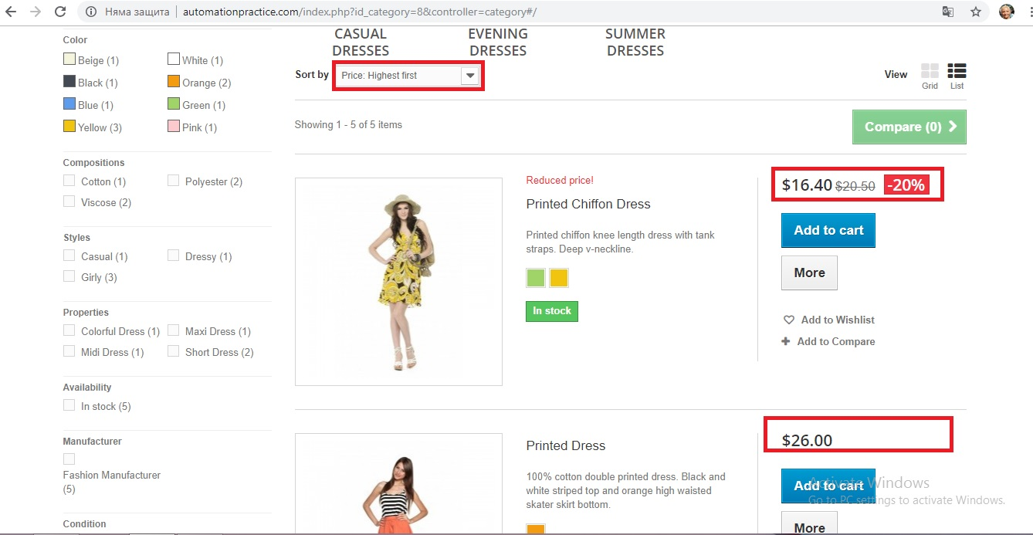
Status | Opened
Component
Version/Build number (Found in)
Environment | Chrome 69.0.3497.100
Comments
Date Created | 10.4.2018
Author | Petya Doncheva
Audit Log

